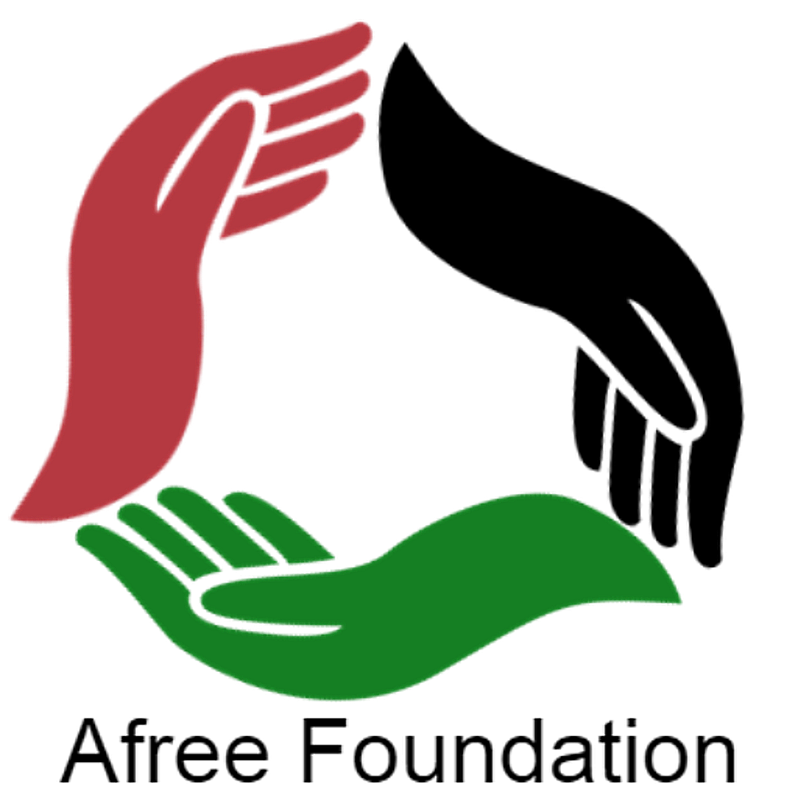 | AFREE FOUNDATION  2026–2027 EDUCATION PROGRAM GRANT APPLICATION  Grant Window: Dec 2026 – Apr 2027 | Award Range: $500 – $2,500 | Execution by: Jan 2028

Important Guidelines & Program Parameters:
• Eligibility: Organizations only (Nonprofits, community education initiatives, learning centers). Not available for individuals.
• Focus Areas: Academic tutoring, STEM/STEAM activities, early childhood education, and GED attainment programs.
• Eligible Uses: Educational supplies & curriculum materials, volunteer stipends, and program equipment.
• Timeline: Applications open December 2026 and close April 2027. All awarded grant activities must be executed by January 2028.
• Submit via Email: info@afreefoundation.org | Subject: 2026-2027 Education Grant - [Organization Name]
SECTION 1: ORGANIZATION PROFILE & CONTACT INFORMATION
Legal Organization/Individual / Program Name: | Organization Type and EIN/TIN/SSN (501c3, School, Community Hub, Individual):
Lead Contact / Program Director: | Title / Role:
Mailing Address: | City, State, ZIP:
Primary Phone Number: | Official Email Address:
Target Student Demographic / Age Group: | Primary Focus: [ ] Tutoring [ ] STEM [ ] Early Ed [ ] GED
Grant Amount Requested ($500 - $2,500): | EIN / Tax ID Number:
SECTION 2: PROGRAM DESIGN & EDUCATIONAL IMPACT
1. Program Overview & Curriculum Goals
Describe your educational program, instructional model, and specific learning outcomes (Tutoring, STEM, Early Childhood, or GED):
2. Student Access, Engagement & Equity
Who are the students/learners served? How does your organization remove learning barriers and ensure consistent participation?
3. Implementation Timeline & Metrics (Completion by Jan 2028)
Outline program milestones, operational schedule, and how success/learning gains will be tracked through January 2028:
SECTION 3: ITEMIZATION & USE OF FUNDS
Detail how grant funds ($500 – $2,500) will be allocated across allowable educational expense categories:
Category | Detailed Description / Item Specification | Estimated Cost
Supplies & Educational Materials (Books, Kits, Software) |  | $
Volunteer & Peer Mentor Stipends |  | $
Educational Equipment & Technology Hardware |  | $
TOTAL GRANT FUNDING REQUESTED: |  | $
SECTION 4: ATTESTATION & SUBMISSION CHECKLIST
[ ] Completed Application Form (Sections 1–4)
[ ] Verification of Organization / Program Entity (Not an individual applicant)
[ ] Executed IRS Form W-9 (Required for all organizational disbursements)
[ ] Commitment to fully execute program activities by January 31, 2028
[ ] Submitted between December 2026 and April 2027 Afreeorganization@gmail.com
I certify that I am an authorized representative of the applying organization and that all statements are accurate. If awarded, funds will be used exclusively for eligible educational purposes and executed prior to January 31, 2028.
Authorized Organizational Representative Signature:  _________________________________________ | Date:  __________________

