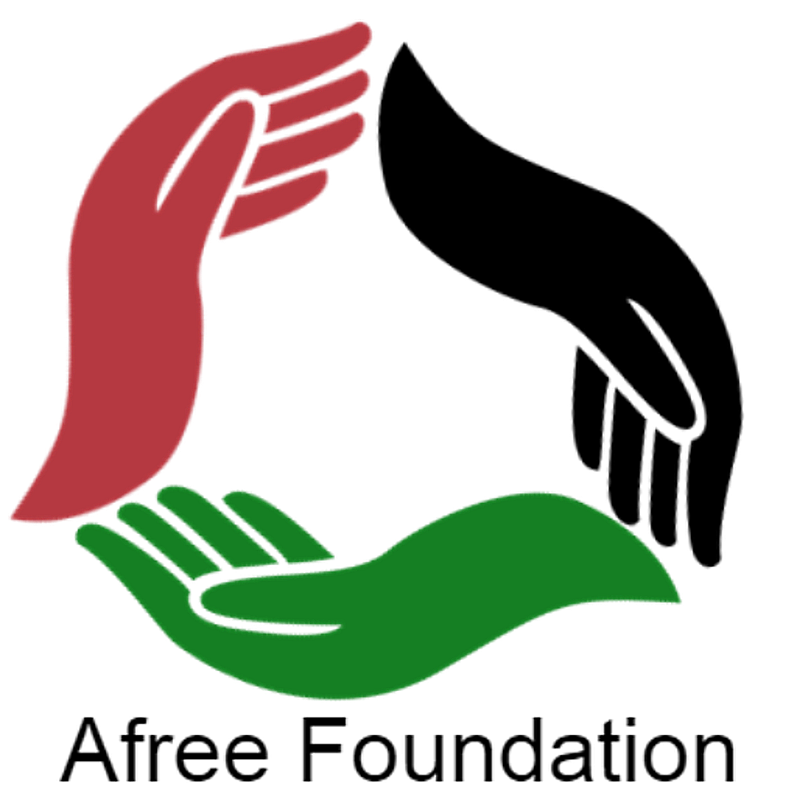 | AFREE FOUNDATION  2026 COMMUNITY GARDEN GRANT APPLICATION  Grant Cycle: Sept 21, 2026 – Dec 21, 2026 (5:00 PM EST) | Award Range: $500 – $1,500

Important Guidelines & Submission Instructions:
• Eligible Uses: Land acquisition/leasing, materials, agricultural supplies, and community advertising.
• W-9 Requirement: If applying for MORE THAN $500, an executed IRS Form W-9 MUST be submitted with this form.
• Deadline: December 21, 2026 at 5:00 PM EST. Late applications will not be reviewed.
• Submit via Email To: info@afreefoundation.org with subject line: 2026 Community Garden Grant - [Project Name]
SECTION 1: APPLICANT & ORGANIZATION PROFILE
Applicant / Project Lead Name: | Title / Role:
Organization / Group Name (if applicable): | Tax Status (501c3, Grassroots, Individual):
Mailing Address: | City, State, ZIP:
Primary Phone Number: | Email Address:
Project Website / Social Media (if any): | Project Physical Address / Location:
Amount Requested ($500 - $1,500): | W-9 Attached? (Required if > $500) [ ] Yes [ ] N/A
SECTION 2: PROJECT DESCRIPTION & COMMUNITY IMPACT
1. Project Title & Executive Summary
Briefly describe the vision and purpose of your community garden project (3-4 sentences):
2. Land Access & Site Readiness
Describe the project site (ownership, lease status, permissions, current condition, and size):
3. Community Engagement & Food Sovereignty
How will local residents, youth, or families participate, access fresh produce, and benefit from this garden?
SECTION 3: ITEMIZATION & USE OF FUNDS
Please detail how the requested grant funds ($500 – $1,500) will be allocated across eligible categories:
Category | Detailed Description / Item Specification | Estimated Cost
Land Acquisition / Lease / Permits |  | $
Infrastructure & Materials (Lumber, Soil, Beds, Fencing) |  | $
Agricultural Supplies (Seeds, Tools, Hoses, Compost) |  | $
Outreach, Flyers & Advertising |  | $
TOTAL GRANT FUNDING REQUESTED: |  | $
SECTION 4: ATTESTATION & SUBMISSION CHECKLIST
[ ] Completed Application Form (Sections 1–4)
[ ] Executed IRS Form W-9 attached (Mandatory for grant requests above $500)
[ ] Proof of land permission/lease or letter of site support (if applicable)
[ ] Submitted prior to December 21, 2026 at 5:00 PM EST to info@afreefoundation.org
I hereby certify that the information presented in this application is true and complete to the best of my knowledge. If awarded, grant funds will be utilized exclusively for the eligible community garden purposes outlined herein.
Authorized Applicant Signature:  _________________________________________ | Date:  __________________

