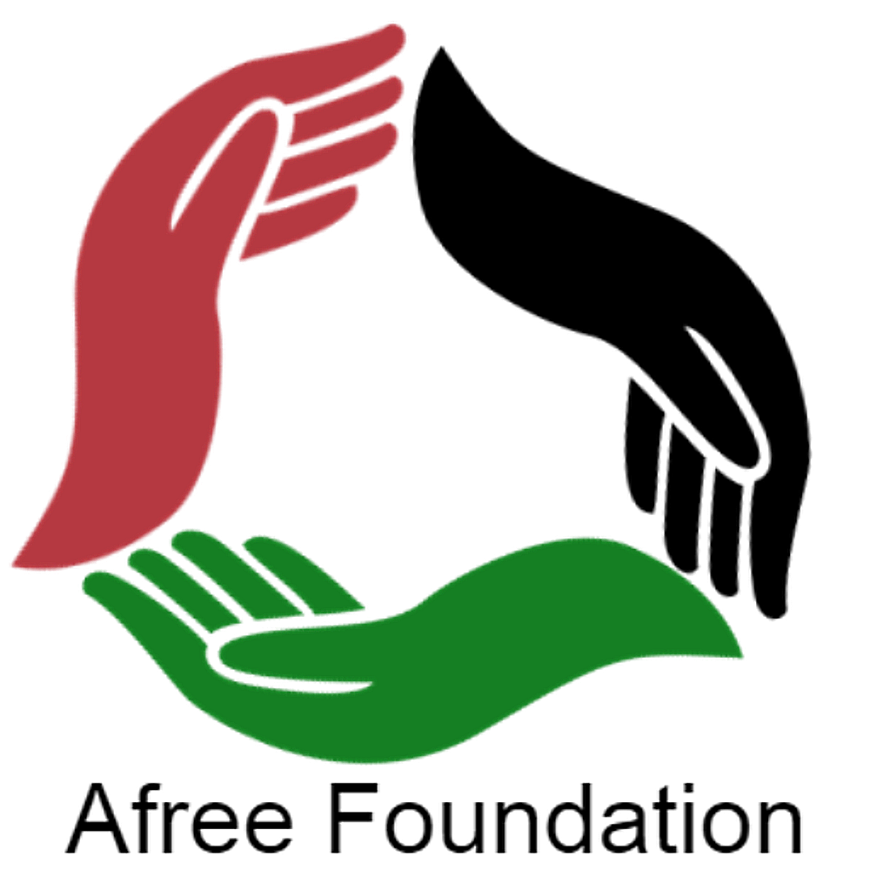 | AFREE FOUNDATION  2026–2027 ARTS & CULTURAL GRANT APPLICATION  Grant Cycle: Nov 2026 – Feb 2027 | Award Range: $500 – $5,000 | Execution by: Feb 2028

Important Eligibility & Grant Guidelines:
• 501(c)(3) Requirement: Grantees must have active 501(c)(3) tax-exempt status (or a verified fiscal sponsor). Grants of $2,500 or more are NOT available for individuals.
• Eligible Uses: Art shows/installations, performing arts (spoken word, theatre, music, dance), marketing, workshops, production.
• Timeline: Applications open November 2026 and close February 2027. All awarded projects must be executed by December 2027.
• Submit via Email: info@afreefoundation.org | Subject: 2026-2027 Arts Grant - [Organization Name]
SECTION 1: 501(c)(3) ORGANIZATION/INDIVIDUALS & APPLICANT PROFILE
Legal Organization/Individual Name: | EIN / Tax ID Number/SSN:
Executive Director / Project Lead: | Title / Role:
Mailing Address: | City, State, ZIP:
Primary Phone Number: | Official Email Address:
Website / Social Media Handles: | 501(c)(3) Status Verified? [ ] Yes (IRS Letter Attached)
Grant Amount Requested ($500 - $5,000): | Fiscal Sponsor Name & EIN (if applicable):
SECTION 2: PROJECT DESCRIPTION & ARTISTIC EXECUTION
1. Project Title & Artistic Vision
Describe the concept, discipline (art show/installation, performing arts, etc.), and goals of the initiative:
2. Community Impact, Audience & Engagement
Who is the primary audience? How does this project elevate cultural expression, community dialogue, and participation?
3. Production Timeline & Execution Plan (Completion by Feb 2028)
Outline key production milestones, venue/location plans, performance/exhibition dates, and marketing rollout:
SECTION 3: ITEMIZATION & USE OF FUNDS
Detail how grant funds ($2,500 – $5,000) will be spent across allowable creative production and outreach categories:
Category | Detailed Description / Line Item Scope | Estimated Cost
Art Shows, Murals & Physical Installations |  | $
Performing Arts (Stage/Sound, Artist Fees, Dancers, Poets) |  | $
Marketing, Promotion, Print Collateral & Digital Ads |  | $
Workshops, Educational Materials & Supplies |  | $
TOTAL GRANT FUNDING REQUESTED: |  | $
SECTION 4: ATTESTATION & SUBMISSION CHECKLIST
[ ] Completed Application Form (Sections 1–4)
[ ] Proof of active IRS 501(c)(3) Determination Letter (or Fiscal Sponsorship Agreement)
[ ] Executed IRS Form W-9 for the individual/501(c)(3) entity
[ ] Commitment to fully execute project by February 28th 2028
[ ] Submit to info@afreefoundation.org between Nov 2026 and Feb 2027
I certify that I am an authorized representative of the applying 501(c)(3) nonprofit organization and that all statements are accurate. If awarded, funds will be used exclusively for the described arts and cultural programming and executed prior to December 31, 2027.
Authorized 501(c)(3) Officer Signature:  _________________________________________ | Date:  __________________

